[GitHib Tutorial](https://www.youtube.com/watch?v=RGOj5yH7evk)

<https://www.youtube.com/watch?v=RGOj5yH7evk>

Github tutorial

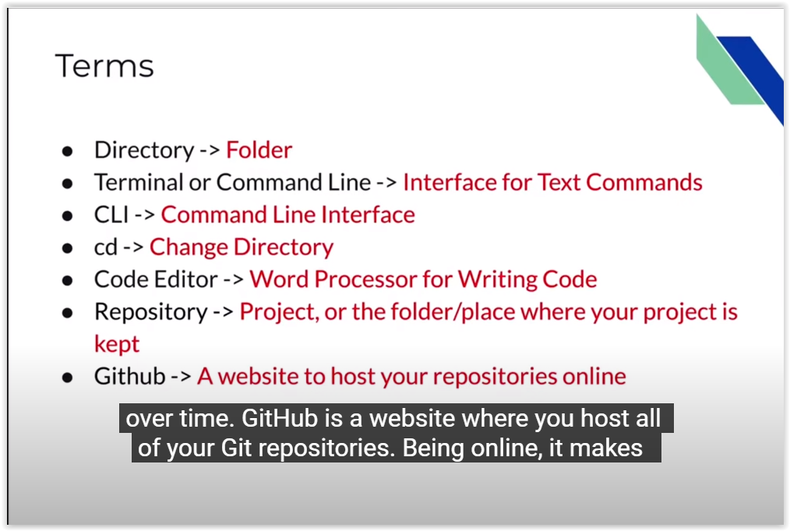

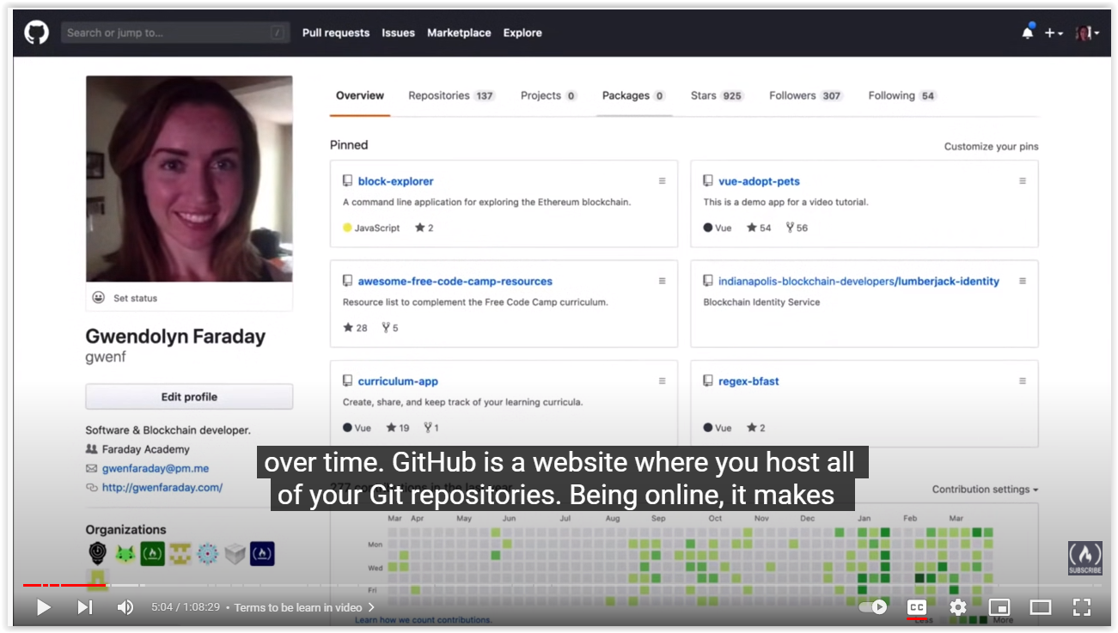

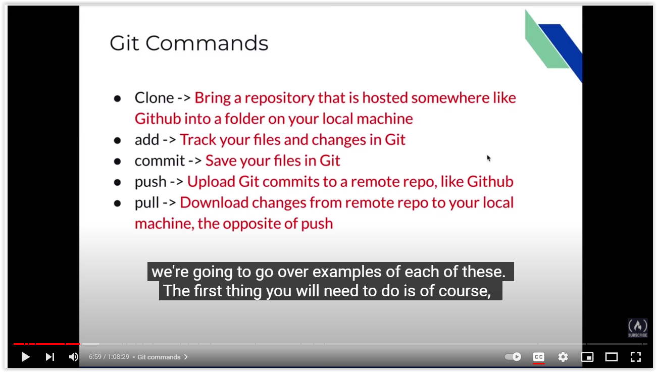

|  |  |
| --- | --- |
| package za.co.business.model; |  |
|  |  |
|  | import java.sql.Timestamp; |
|  |  |
|  | import javax.persistence.Column; |
|  | import javax.persistence.Entity; |
|  | import javax.persistence.GeneratedValue; |
|  | import javax.persistence.GenerationType; |
|  | import javax.persistence.Id; |
|  | import javax.persistence.Table; |
|  | import javax.validation.constraints.NotBlank; |
|  |  |
|  | @Entity |
|  | @Table(name = "configuration") |
|  | public class Configuration { |
|  |  |
|  |  |
|  |  |
|  | @Id |
|  | @GeneratedValue(strategy = GenerationType.IDENTITY) |
|  | private Long configurationId; |
|  |  |
|  | @Column(name = "date_created") |
|  | private Timestamp dateCreated; |
|  |  |
|  | @NotBlank |
|  | @Column(name="company_name", unique=true) |
|  | private String companyName="Company Name"; |
|  |  |
|  | @Column(name="branch_name") |
|  | private String branchName; |
|  |  |
|  | @Column(name="branch_phone") |
|  | private String branchPhone; |
|  |  |
|  | @Column(name="industry") |
|  | private String industry; |
|  |  |
|  |  |
|  |  |
|  | public Timestamp getDateCreated() { |
|  | return dateCreated; |
|  | } |
|  |  |
|  | public void setDateCreated(Timestamp dateCreated) { |
|  | this.dateCreated = dateCreated; |
|  | } |
|  |  |
|  | public String getCompanyName() { |
|  | return companyName; |
|  | } |
|  |  |
|  | public void setCompanyName(String companyName) { |
|  | this.companyName = companyName; |
|  | } |
|  |  |
|  | public String getBranchName() { |
|  | return branchName; |
|  | } |
|  |  |
|  | public void setBranchName(String branchName) { |
|  | this.branchName = branchName; |
|  | } |
|  |  |
|  | public String getBranchPhone() { |
|  | return branchPhone; |
|  | } |
|  |  |
|  | public void setBranchPhone(String branchPhone) { |
|  | this.branchPhone = branchPhone; |
|  | } |
|  |  |
|  | public String getIndustry() { |
|  | return industry; |
|  | } |
|  |  |
|  | public void setIndustry(String industry) { |
|  | this.industry = industry; |
|  | } |
|  |  |
|  | public Long getConfigurationId() { |
|  | return configurationId; |
|  | } |
|  |  |
|  | @Override |
|  | public String toString() { |
|  | return "Configuration [configurationId=" + configurationId + ", companyName=" + companyName + ", branchName=" |
|  | + branchName + ", branchPhone=" + branchPhone + ", industry=" + industry + "]"; |
|  | } |

**EDDIE JAOUDE – GIT**

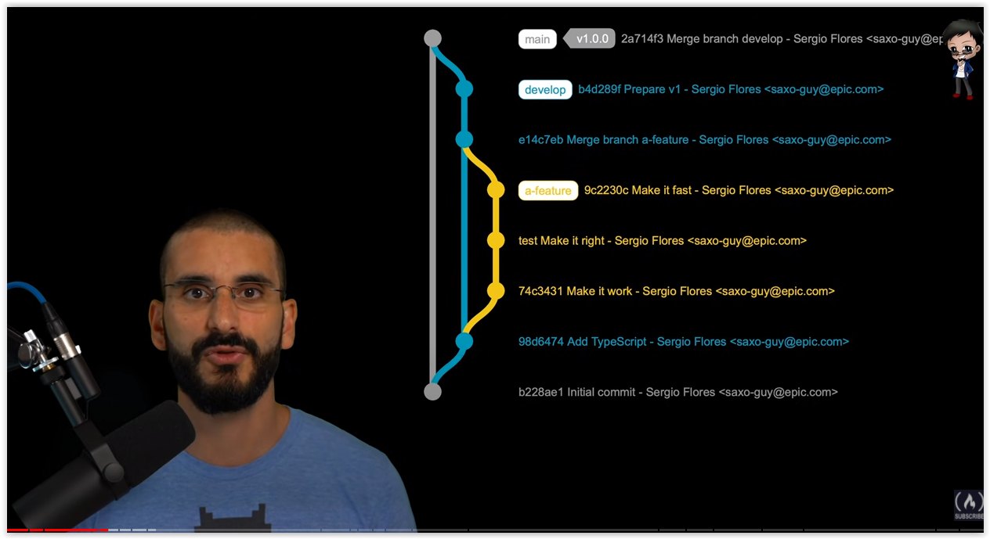

Profile Page

